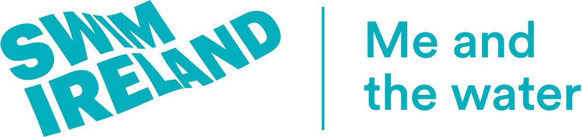
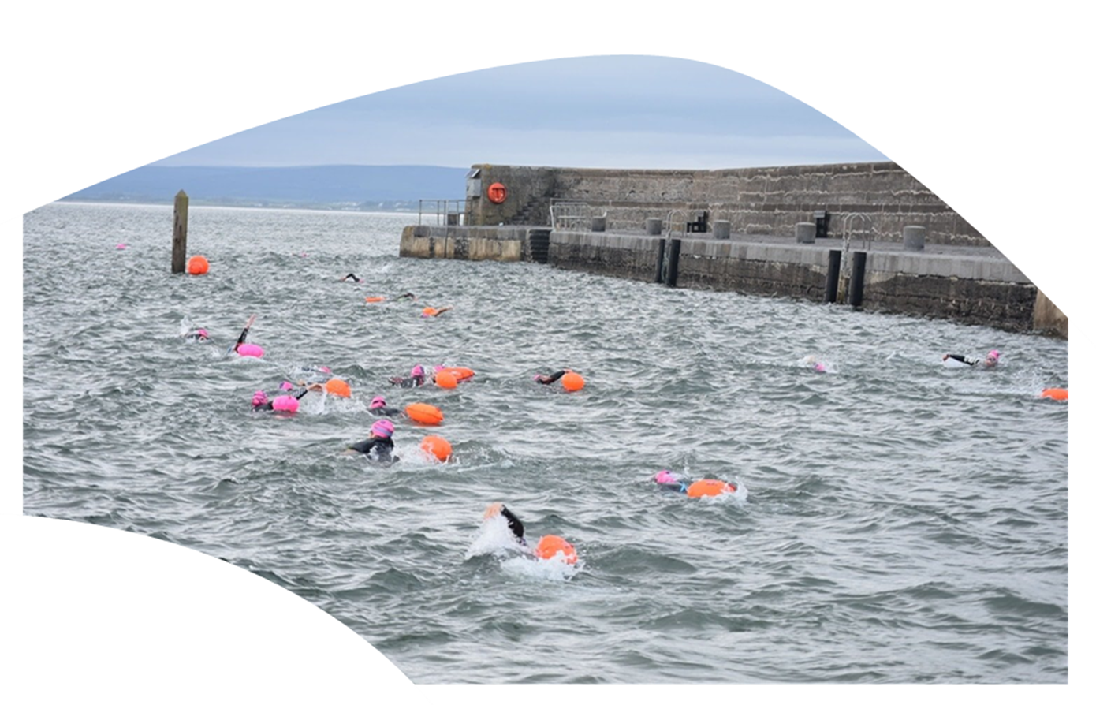

Open water events will return to the Republic of Ireland on June 7th. The maximum number permitted per event is currently 200. This includes participants, officials and event organisers.
Swim Ireland Open Water Swimming

COVID-19 Return to Water Framework

Open Water Event Protocols

Updated 1st June 2021

In Northern Ireland the maximum number of participants allowed at open water events in Northern Ireland increases from 100 to 500 from May 24th.

Under Swim Ireland’s framework developed from Sport Ireland’s guidelines, events will be able to proceed under social distancing and other COVID-19 prevention measures.

Support is available to all event organisers from Swim Ireland to ensure their events follow these requirements.

Fundamental Decisions Required Before Returning to Water
- COMPLIANCE WITH CURRENT COVID-19 RESTRICTIONS – Swim Ireland clubs and members need to make themselves aware of COVID-19 restrictions that are in place at the time of returning to water.

- PERSONAL RESPONSIBILITY – Each person is to take personal responsibility for their own health, safety and decision making; it is of utmost importance that any person who thinks they may be symptomatic should stay at home and not partake in activity until cleared to do so.

- RISK ASSESSMENT – Individuals, clubs and the associated workforce must ensure that they have assessed the risks associated with the venues open water conditions, equipment in use and the experience which the attendees will have in their return to open water swimming and for those who are new to the sport.

Guidance for Event Organisers (ROI)
The maximum number permitted per event is currently 200.
This number includes participants, officials and event organisers.

It may be possible for event organisers to facilitate larger numbers of overall participants using waves/pods.

The key principle in any instance of a congregation of not more than 200 people in one area before, during or after an event must be upheld.

Events may take place with spectators following social distance guidelines and numbers should not exceed 200

Events must take place in adherence to Swim Ireland’s Covid-19 Event Protocols.

Race Structure
Events can implement a system of a socially distanced race structure for participants ie: participants can commence their race at a different start time.

Should event organisers wish to implement a race structure (e.g. waves/pods/handicap), a sufficient time gap should be in place to guarantee that at no time would gatherings of more than 200 people take place.

The time gap required will vary between ages, abilities and events however event organisers should take a cautious approach with a clearly defined structure. Clear guidance must be issued to participants regarding their start time within the race structure.

Leisure events/participation events
Organisers should segregate participants by estimated average speed (e.g. set the fastest wave off first). A time gap is recommended depending on ability, time, age etc. The time gap will need to increase if there is the risk of a congregation of more than 200 people before, during or after the event.

Contact Tracing
Organising Committees must appoint a COVID-19 Officer/Committee to ensure compliance with this guidance and Governmental directive, to establish the groups referenced above and to ensure that Contact Tracing is enabled as follows:

A key point in public health measures is to ensure that there are clear records at all times of who was in the water at each event and who else was present (as part of the event organisation, e.g. Officials, volunteers, safety personnel). These records should be kept digitally in order that they can be transferred easily. This is vitally important to ensure that contact tracing is provided for in the event of a case of the virus presenting itself in one of the participants.

Participants must ensure that they are fully cognisant of the following recommendations and advice, in association with any other conditions and requirements set by the organising club/region, Swim Ireland, Sport Ireland, the HSE/HSC and/or the Government in the return to Open Water swimming. It is important that the below recommendations do not supersede any Government/HSE/Irish Coast Guard/HSC/ directives in relation to restriction of movement and/or access to bodies of water.

Current HSE/HSC advice in relation to the impact of COVID-19 in open water (freshwater and saltwater) suggests that the risk of transmission of the virus through water is low. The HSE National Bathing Water Group regularly review and update their guidance relating to Bathing Water and Health. There has been no specific assessment to date on the viability of the virus on water sport clothing or equipment however it is recommended that all equipment in stored in well ventilated areas and are frequently disinfection to reduce any potential risk of transmission.

Open Water Racing Guidance
This Open Water Racing Guidance is designed to help minimise any risk but does not remove risk completely.

Personnel should not take part in an event if any cold or flu symptoms are being experienced and should seek medical advice and should self-isolate until their status is determined.

Swimmers/Event Personnel should adopt good respiratory hygiene, covering their nose and mouth when they cough or sneeze.

Prior to Each Event
- All COVID-19 provisions in place should be communicated to all participants and Event Personnel (Officials/Volunteers/Safety Personnel) in advance of the event taking place.
- Spectators are not permitted to attend.
- Where events include entrants under the age of 18 year-olds a responsible person should attend with them (with a responsible person being a parent or designated guardian over the age of 18) who must be included in the permitted numbers.
- Prior registration (online) is required and organising committees must collect contact information from each participant to assist with contact tracing.
- All those who will be attending (participants, officials, management, support personnel) are required to complete health screening within 24 hours of the event on line.
- COVID-19 health advisories should be displayed at the event; also consider markings on the ground.
- Event Personnel and participants should adhere to the current government guidance on social distancing in open spaces.
- No hand shaking or similar contact greetings to occur.
- Event Personnel should use face coverings and consider wearing rubber/disposable gloves provided by the Organising Committee.
- Participants must use face coverings at registration or in any enclosed area.
- Hand sanitiser should be accessible in all common areas.

Guidance for Participants
- Swimmers should adhere to the government guidance on social distancing in open spaces.
- Swimmers should adhere to instructions on dressing areas and dressing points.
- Swimmer should try and restrict swimmer body contact when in the water.
- Swimmers not to share drinks or foodstuffs prior to, during or after event.
- Drinks bottles to be clearly marked for ownership and ideally left in participants bag.
- Swimmers to only use their own equipment.
- Swimmers should not loan personal equipment or caps/goggles to each other.
- Swimmers should adopt good respiratory hygiene, covering their nose and mouth when they cough or sneeze.

Guidance for Event Organisers
- Event Personnel should be kept to a minimum while ensuring the event can run safely and smoothly.
- Event Personnel should be educated on social distancing protocols and other requirements.
- Registration should be online in advance of the event with race day check in only.
- Event Personnel should restrict the number of people at the check in area, social distancing in relation to available venue area space must be considered when determining the numbers.
- For any case where persons are not following the established prevention procedures in relation to COVID-19, they should be asked to leave the event
- Ensure Registration Staff and Volunteers have Personal Protective Equipment available to wear
- If in use,
  - timing chips and velcros must be disinfected according to the recommendation from the manufacturers.
  - ensure that the timing provider has safety measures in place to ensure social distancing during issue of timing equipment
- Staggered check in times should be used to ensure social distancing can be maintained at check in.
- Consider spacing marked on the ground for queuing.

Guidance for Safety Crews
- Wear gloves and face shields/masks/helmets with visors down (boat crews)
- Use equipment such as torpedo buoy if possible.
- Have stock of masks on the boat for swimmers to wear.
- Follow PHECC advice in relation to first aid and CPR if required.

Bag Drop Off/Collection
We recommend that there is no bag drop area (or transportation of bags for a point to point race) in the first instance.
- Provision should be made for a competitor changing area, where bags can remain for the duration of the swim. It is important that this area is outside and provides adequate space for participants to adhere to social distancing and do not congregate in groups.
- Event organisers should have stewards patrolling the competitor changing area at all times.

The Race
- All race information should be provided to swimmers online prior to the event date along with all guidelines concerning event policies and procedures, assigned check in and race times, increased hygiene measures etc.
- Safety briefings should be recorded by video or presentation/document and made available online prior to the event. Event briefings on the day should also be provided to ensure all safety measures are covered i.e., weather conditions, tides etc. Please ensure these are conducted in line with social distancing guidelines.
- It is recommended that all events implement a rolling start system in specific start waves with the provision of a waiting area for the athletes respecting social distancing. Race organisers to decide on best way to distance participants based on available space.
- Swimmers are not permitted to line up outside their allocated race time.
- The finish should be sufficiently wide enough to allow for social distancing and should open into a wide area where swimmers can recover.

Note
This is a guidance document only.
This document is for the benefit of Swim Ireland members, clubs, and event organisers as information.
This document is not legal advice or intended as a substitute for any applicable government advice. It is also not a substitute for clubs/members/users who should carry out their own full risk assessment and review.
Swim Ireland does not give a warranty or undertaking as to the advice in this document.

This document will be updated following revised government advise as we move into the next phase/step of the roadmap.

June 2021

